**6.3 Liquid crystals**

Liquid Crystals (LC) possess properties of both the conventional liquids and solid crystals. They find application in the areas of science and engineering, particularly in display systems of modern electronic gadgets. Devices using liquid crystal displays have the advantage of low power consumption and hence are widely used in display devices of mobile communication appliances, aircraft cockpit, laptops and other electronic equipments.

In a crystalline state, the molecules (or atoms) are having a definite position and orientation in space in a regular repeated manner in a rigid arrangement and are immobile. They tend to orient in a preferred direction i.e., the molecules in solids have a positional and orientational order. In the liquid state, the molecules neither occupy specific positions nor remain oriented in a particular manner. The molecules are somewhat free to move at random and collide with one another, abruptly change their positions. The liquids have neither positional order nor orientational order. A liquid crystal (LC) is a state of matter exists between solids and liquids with both the properties. Normally when a low molar mass solid melts, it forms an ordinary liquid and is isotropic. Organic substances which are geometrically anisotropic i.e., long and relatively narrow molecular shape exhibits this intermediate state of order between solid crystals and isotropic liquids. They undergo more than a single transition in passing from solid to liquid through different intermediate states on heating. These intermediate states with different molecular ordering are also known as mesophases, derived from a Greek word, *mesos* meaning middle. In mesophase state either the individual molecules align with respect to each other or exhibit some regular position with respect to each other. The molecular arrangement in solids, liquid crystals and liquids can be represented as below.

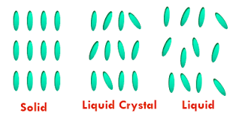

In a liquid crystal, the molecules possess orientational order, i.e., the molecules tend to remain oriented in a particular direction. The direction of preferred orientation in a liquid crystal is called the **director ()** and may be imagined to be directed towards the top or bottom of the page. Since the molecules are in constant motion, in liquid crystal phase they spend more time pointing along the director than along any other direction. The extent of orientational order can be described by taking an average. An average of 0° indicates perfect orientation and can be expected in solids. An average of greater than 45° indicates no orientational order and found in liquids. However, in liquid crystals, a smaller average angle with the director is observed which indicates orientational order.

The quality of any device using LCs depends mainly upon the ***physical properties*** of the LC molecules. To achieve a high performance of the LC device, it is essential to select the most appropriate LC material according to the specific requirements of the desired device. In general, the LCs must satisfy the followingcharacteristic properties

1. Liquid crystalline nature should be at room temperature and the entire temperature range of the device operation
2. Chemically, electrochemically, photochemically and thermally stable
3. Permanent electric dipole
4. Should possess easily polarizable substituents

**6.3.1 Classification of Liquid Crystals**

Based on the response to temperature or concentration, Liquid Crystals are broadly classified as

* + Thermotropic LCs
  + Lyotropic LCs

The liquid crystalline substances which undergo transitions by variation in temperature are called thermotropic LCs. Eg. p-azoxyanisole. The liquid crystalline substances which undergo transitions by the influence of solvents are called lyotropic LCs. Eg. sodium stearate. Both these systems can be characterized by anisotropic viscous, electrical, optical and mechanical properties. Organic molecules, which are able to form thermotropic as well as lyotropic mesophases, are termed as amphotropic LCs.

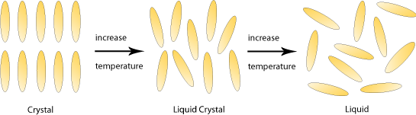

***Thermotropic Liquid Crystals:*** Based on the mesophase, the TLCs are further classified as

1. nematics
2. smectics
3. columnar
4. cubic

***Nematic:*** The properties of this phase are very close to liquidor they possess most liquid-like structure. The molecular axes are oriented parallel to one another, resulting in a long range of an orientational order. They do not possess positional order.

***Smectic:*** The properties of this phase are very close to solid.They possess layered structures with many possibilities of the state of order inside the layers. They show long-range orientational as well as partial positional order.

***Columnar:*** Structures with columns consisting of parallel arranged disc-like molecules.

***Cubic:*** Structures with micellar lattice units or complicated interwoven networks.

Based on the shape of the constituting molecules, the thermotropic LCs can be further classified as

1. *Calamitic LCs*
2. *Discotic LCs*
3. *Polycatenar LCs*
4. *Bent (Banana* ) *LCs*

**Calamitic Liquid Crystals:** The LC compounds possessing rod-like molecular shape belong to this category. The general molecular structure of a calamitic LC is as given below.

A

B

C

D

L

L

L

Rʹ

Rʺ

Where A, B, C, and D are called the rigid cores (containing a phenyl, biphenyl, naphthyl, cyclohexyl or five/six-membered heterocycles) of the molecule. In a Liquid crystal, there should be at least one rigid core.

‘L’ is the linking group (an imine, azo, azoxy, ester, thioester, C=C, and C≡C)

Rʹ or Rʺ is the end group/chain (a halo group, cyano, nitro, alkyl or alkoxy groups)

Some examples of the calamitic LCs are given below.

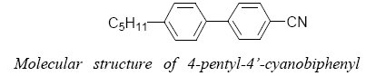



*(perfluorodecyl)-decane*

**Discotic Liquid Crystals:** Discotic compounds consist of flat and disc-like rigid cores which are surrounded by flexible chains such as alkyl, alkyloxy or alkanoyloxy. These discotic molecules can be stacked one over another in many ways so as to obtained different columnar structures like hexagonal, rectangular or oblique symmetry. Within the columns, the molecules can have a certain order or disorder. The general structure of discotic LCs can be represented with the following cartoon picture.

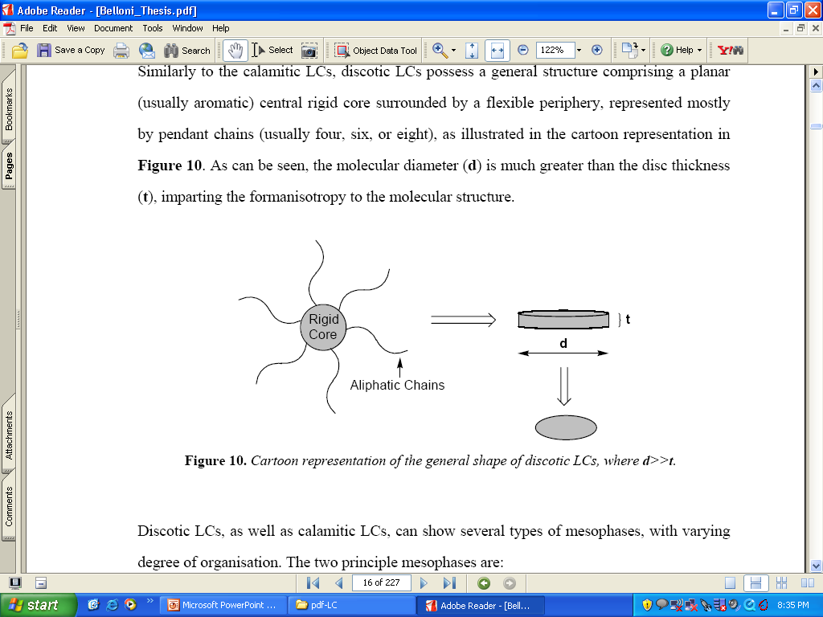

In discotic liquid crystals, the molecular diameter (d) is much greater than the disc thickness (t) to form anisotropy. A typical molecular structure of a discotic molecule is shown below.



**Polycatenar Liquid crystals:** Polycatenar mesogens are considered as a hybrid class of thermotropic LCs, as its molecular features lie intermediate between classical rod-like and disc-like mesogens. Schematically the central core of polycatenar LCs comprises a calamitic region, with half-discs on the extremities. This hybrid molecular structure allows them to exhibit both calamitic (nematics/smectic) and discotic (columnar) phases, depending on the specific molecular structure of the components. E.g., the tetracatenar mesogens (shown below), at shorter chain lengths exhibit nematic and/or smectic-C phases, while at longer chain lengths exhibit columnar phases. The numbers of the flexible end chains of the core can be indicated by using the term, *m,n*–polycatenary mesogen. The different polycatenar LCs can be represented with the following schematic diagrams.

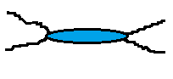 

2,2-polycatenary mesogen 3,1-polycatenarymesogen

**Bent (Banana) Liquid Crystals:** Bent (Banana) shaped liquid crystals are constituted of two mesogenic groups linked through a rigid core in such a way that the molecule is not a linear (as shown in the following figure). The central rigid core (Z) may be a phenyl or biphenyl or naphthyl group. The mesogenic groups attached to the central core are mostly the calamitic molecules consisting of two (or more) aromatic rings with different linking groups (A, B, X, Aʹ, Bʹ, Xʹ) and a terminal chain/a substituent in para position to the linking group of the aromatic rings. The angle between the two calamitic wings (bending angle) is around 120°. In case of a benzene central core, the mesogens are connected in 1 and 3 positions (i.e., meta position to each other). If the central core is a naphthyl, the two calamitic wings are connected in 2 and 7 positions.



***Lyotropic Liquid Crystals:*** Lyotropic liquid crystals are formanisotropic aggregates when combined with a solvent, like water. The phase behavior is dependent on the concentration and polarity of solvent and also on the temperature. Molecules which form lyotropic phases are usually amphiphilic, having non-polar, hydrophobic "tails" at one end with a polar, hydrophilic "head" at the other end. Some examples are sodium stearate (soap) and phospholipids. The concentration of material in the solvent and the response of the amphiphile to the solvent environment dictate the type of lyotropic phase formed. For example, in a polar solvent like water, micelles are formed in which the hydrophobic tails assemble together and the hydrophilic heads groups are presented to the solvent. When combined with a non-polar solvent such as hexane, an inverse micelle is formed where the hydrophobic tails shield the hydrophilic head groups from the non-polar environment. Under certain conditions, these micelles further aggregate to form more complicated assemblies, such as lamellar and hexagonal Phases, which generate lyotropic liquid crystal phases. Lamellar phases are particularly significant as they form the structural basis for biological membranes

*Examples of Lyotropic liquid crystals and their phase structures*

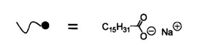 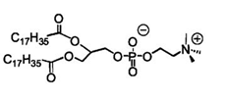

Sodium Sterate

Phospholipid

Micellar aggregates and phase structures formed by Lyotropic liquid crystals are shown below.

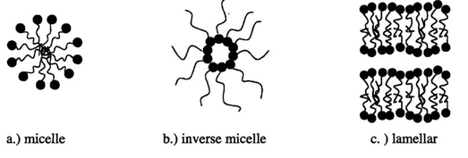

**6.3.2 Applications of liquid crystals:**

Liquid crystal displays operate at low voltages (a few volts) and consume less power as compared to other displays and hence are used in:

1. Liquid crystal displays: Used in display devices such as watches, calculators, mobile telephones, laptop computers, and clocks.
2. Liquid crystal thermometers: Chiral nematic LCs reflect light and the color which is reflected is temperature dependent.

**6.3.3 Liquid Crystals in Display systems**

The electro-optic effect of liquid crystals controls the brightness/darkness of the light emerging from its elements and this is used in information displays. Information is passed on to the user using LCs which control the brightness/darkness of the parts of a display. Liquid Crystal Displays are available in many sizes and can be used to display numeric, alphanumeric and graphic images. The numeric display has seven segments whereas alphabets are displayed using fourteen segments. More complex graphic images are formed using pixels (picture elements) which are closely packed array of dots in two dimensions.

A numeric display consists of seven segments for each digit. Light from the area of each of the seven segments is controlled independently and is used to create any one of the ten digits. When an electric field is applied to a segment, the liquid crystal in that segment undergoes deformation (is activated) and when polarized light is incident, the light is modulated depending on the deformation in that segment.

In twisted nematic displays (TND), the nematic LC is sandwiched between two ITO coated glass plates with parallel (homogeneous) alignment of its molecular director with the glass walls. However, the two glass plates are twisted by 90° relative to each other (as shown in the following figures).

Electric field off

Electric field on

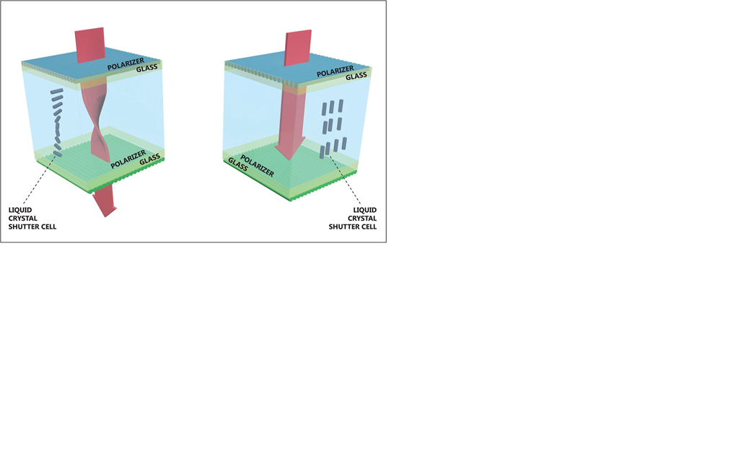

In such geometry, the LC is forced to perform a 90° twist of the director resulting in a helical structure. The distance between the plates, hence the thickness of the LC film, is typically 6–10 µm. To complete the TND unit, a pair of crossed polarizers is placed on the outer side of the glass plates. In the absence of an external electric field, when linearly polarized light enters the device, the LC film rotates the polarization of the light by 90°. Thus, the light reaches the second polarizer with its polarization plane parallel to the polarizer axis and is transmitted. In this configuration, the display appears bright (off-state). However, when an electric field is applied (on-state), the 90o twist in the cell is lost and the LC molecules reorient in order to align the molecular director with the external electric field, causing the helical arrangement to be unwound. As a consequence, the light passing through the LC film is not guided through 90° and is not able to pass through the second polarizer. The display looks dark and the observer can see the black character on a silver gray background.